**Predictive Maintenance for Industrial Equipment (COMP4436-25-P3)**

**Creator:** Lee Ming Hin

**Introduction**

Our system uses sensor data and machine learning to detect equipment anomalies before failures occur, reducing downtime and maintenance costs in industrial settings. It monitors temperature, vibration, and pressure to identify early warning signs of equipment malfunction.

**Methodology & Process**

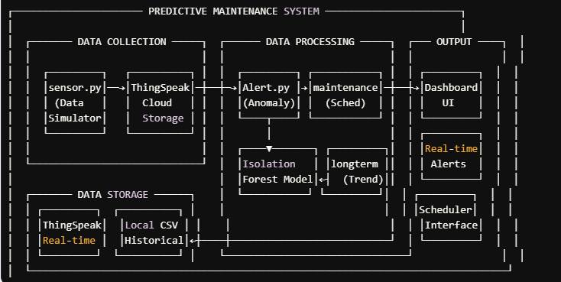

**Data Collection:**

* Python-based sensor simulation for turbines and compressors
* ThingSpeak cloud platform for data storage and visualization

**Data Processing:**

* Isolation Forest algorithm for anomaly detection
* Separate models for turbine (temp/vibration) and compressor (pressure) equipment
* Live evaluation of sensor data against trained models

**Output System:**

**一張含有 文字, 螢幕擷取畫面, 字型 的圖片

AI 產生的內容可能不正確。**一張含有 文字, 螢幕擷取畫面, 功能表, 字型 的圖片

AI 產生的內容可能不正確。

**Results**

一張含有 文字, 圖表, 螢幕擷取畫面, 字型 的圖片

AI 產生的內容可能不正確。

**Code Repository**

GitHub: [Predictive-Maintenance-for-Industrial-Equipment](https://github.com/KennyHacrt/Predictive-Maintenance-for-Industrial-Equipment-/tree/main)